Patient Name:

DOB:

HPI:

History:

Physical Exam (morphology & location):

Assessment & Plan (treatment plans):

Counseling:

FEMALE:

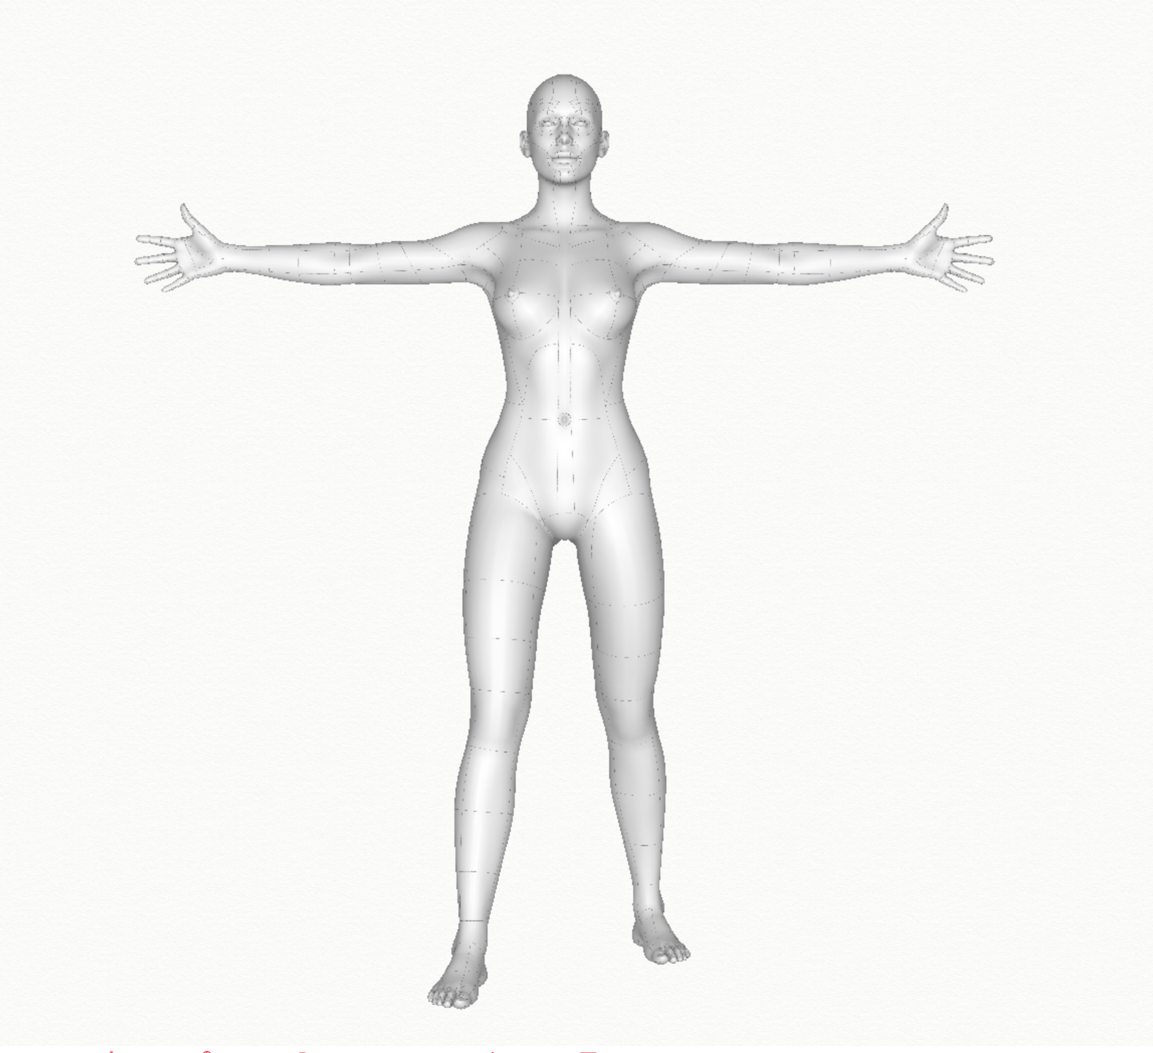

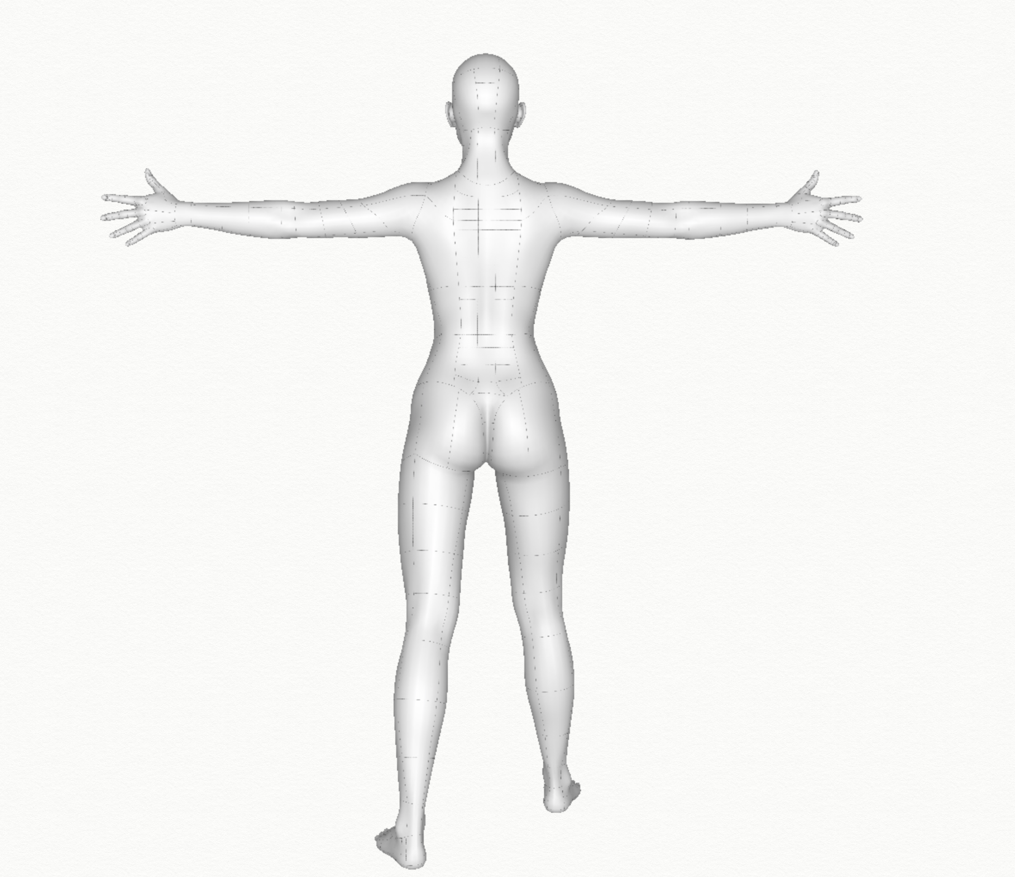

MALE:

